CHAPTER 1 - JAVA SWING PROJECT

Installation of Java Development Kit :
- Check whether java is present on your PC if so uninstall it.
- Now go to the link https://www.oracle.com/technetwork/java/javase/downloads/jdk11-downloads-5066655.html
- From there follow this video tutorial to install jdk on your PC
https://www.youtube.com/watch?v=LlLRjFptXAY
- ERROR! : javac not recognized as an internal or external command, operable program or batch file.
- To solve this error you need to set the environment variables by going to the properties of The PC->Environment Variables->New(under use variable for hp)->set variable name as PATH->set variable value as address of the bin(In C drive JAVA jdk inside that bin)
- Click OK for both dialog boxes
- Type javac on the command prompt and this error will get solved.
Running a java Program :
- Create a java program
Class name : Hello
Program name : abc
- Open the directory where it is saved in command prompt ,Compile Program(convert to byte code)
javac abc.java
- You can now open the directory and you can see A.class class file
- Execute the program
Java Hello
- Now, you have successfully run the program

Creating radio buttons, label and frame :
For this you can refer to tutorial
https://www.javatpoint.com/java-jradiobutton
You need to create
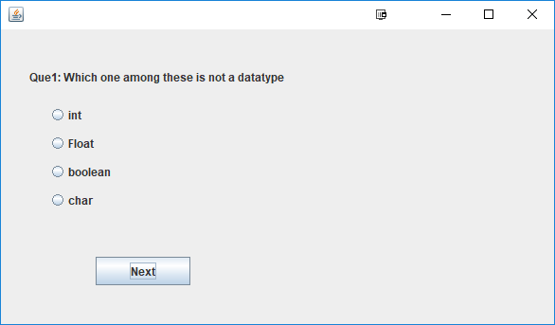a page like this

The code for this one is given here :

//code:start

import javax.swing.JFrame;
import javax.swing.JLabel;
import javax.swing.ButtonGroup;
import javax.swing.JCheckBox;
import javax.swing.JRadioButton;

public class label {

label() {
JFrame frame= new JFrame("Quiz app");
JLabel label;
label=new JLabel("Ques 1 : Which one of these is not a data type ?");
label.setBounds(50,50, 680,30);

frame.add(label);
frame.setSize(400,400);
frame.setLayout(null);
frame.setVisible(true);
JRadioButton r_int = new JRadioButton("int");
JRadioButton r_float = new JRadioButton("float");
JRadioButton r_bool = new JRadioButton("boolean");
JRadioButton r_char = new JRadioButton("char");

r_int.setBounds(80, 100, 100, 20);
r_float.setBounds(80, 130, 100, 20);
r_bool.setBounds(80, 160, 100, 20);
r_char.setBounds(80, 190, 100, 20);
ButtonGroup btn_grp = new ButtonGroup();
btn_grp.add(r_int);
btn_grp.add(r_float);
btn_grp.add(r_bool);
btn_grp.add(r_char);
frame.add(r_int);
frame.add(r_float);
frame.add(r_bool);
frame.add(r_char);

frame.setSize(600, 600);
frame.setLayout(null);
frame.setVisible(true);
frame.setSize(600, 600);
frame.setLayout(null);
frame.setVisible(true);
JButton b=new JButton("Next");
b.setBounds(100,230,95,30);
frame.add(b);
frame.setSize(400,400);
frame.setLayout(null);
frame.setVisible(true);
}

public static void main(String[] args) {
// TODO code application logic here
// JFrame frame= new JFrame("Quiz app");

new label();
}
}
//Code: End

